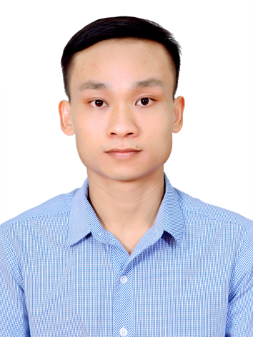
LE DUC HUY

Applying Position: PQA Engineer
CONTACT INFORMATION
Full name: Le Duc Huy
Date of birth: 18/09/1990
Sex: Male
ID card No: 031090010309
Address: Thien Kha, Quyet Thang, Hai Phong
Mobile: 034.456.9966
Email: huy33391@gmail.com

CAREER OBJECTIVE
With a background in mechanical design, 8 years in QC, and 10 years in programming, I am seeking the Part Quality Assurance (PQA)position. My goal is to optimize inspection processes using digital solutions, while sharpening my leadership skills to directly contribute to the growth and success of Tohoku Pioneer Company.
WORK EXPERIENCE
IQC staff
KYOCERA Document Technology Hai Phong (28/9/2021 to PRESENT)

- Make inspection guidelines based on drawings.
- Train workers to perform inspections based on established guidelines.
- Update inspection guidelines when issue happen.
- Co-work with related team to find root cause and make corrective action for quality issues related component.
- Performing other management tasks as required by my Team leader.

- Improvements projects:
- Developed a voice-to-text tool for IQC team to input inspection result: Highly appreciated by the General Manager, who requested the IT department to apply it for other departments.
- Developed a system to support fill entry into inspection records: Reduced 3840 hours/year: Awarded the Outstanding Kaizen of the Year by the General Manager.
- Developed an automated system for submit inspection results: Reduced 1232 hours/year.
- Using AI to developed software for automated split data suppliers.
- Training for IQC staff:
- VBA programming training.
- Training on how to create charts on reports.
- Training on using Excel, PowerPoint, Word, and how to create reports.

IVI QA staff
LG Electronics Vietnam Haiphong (15/04/2018 to 27/09/2021)

- Coordinating cross functional teams (CFT) to handle quality issues.
- 4M change management.
- Program many macros, software to automatic some our jobs.
- Report quality issues with my Team Leader weekly.

EDUCATION
- 10/2008 – 05/2013 Vietnam Maritime University in Hai Phong City (Specialty: Naval Architect - Specialized in structural analysis, design calculations, and technical drawing production).

HONORS & AWARDS
- Scholarship in 1st semester 2010 – 2011.

PROFESSIONAL SKILLS
- I have 8 years’ experience about QA Engineer & 10 years’ experience about programming.
- Able to use hand measurement tools (calipers, micro-meters, highgate (H/G), MM machine, block gauge, pin gauge, S/R, Th/G…).
- Specialist in macro, VBA Excel programing, Python, C#, VB.net.
- Use UiPath to develop the automatic tool to reduce working time for Operator.
- Use QC 7 Tools, FIFO, 5S, 5 Why, 8D report, Logic tree as well as technical skill on report, analysis, solve problem.
- Working knowledge in PFMEA, Control Plan, WI.
- Computer software very proficiency: MS Office, Internet.
- Good command in English.
- Able to read engineering drawings.
- Able to work independently and within a team under pressure.
- Quick-learner, self-confident and active.
- Hard working, well-organized and high sense of responsibility.
HOBBY
- I like jogging, workout with my friends.

